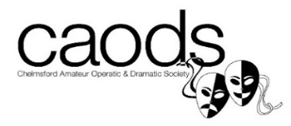

TOP HAT 2018
AUDITION FORM
Name:
Address:
Postcode:
Home Number:
Mobile Number:
Email Address:

AUDITIONING FOR:
CONSIDER FOR UNDERSTUDY: YES / NO (please circle)

I WOULD LIKE TO BE CONSIDERED FOR:

I AM AUDITIONING FOR A DANCER*: YES/NO (please circle)
I AM AUDITIONING TO TAP & ENSEMBLE: YES/NO (please circle)
I AM AUDITIONING FOR ENSEMBLE ONLY: YES/NO (please circle)
* (Anyone auditioning for a dancer and has not auditioned for a principal singing role will also need to audition for the Ensemble vocal).
Please list any holiday dates or rehearsals that you are unable to attend:

I can attend the Publicity Day at Hylands House on Sunday 5 August 18: YES/NO
I can attend the Publicity Day at Bond Street on Saturday 1 September 18: YES/NO

Please submit this form no later than Friday 11 May 2018 to Chairman of the Audition Panel, Claire Carr, by HAND or EMAIL clairecarr@sky.com Thank you!

PLEASE NOTE: re SOCIAL MEDIA TAGGING: We assume you hereby give your consent to be tagged in any Social Media Publicity Campaigns for TOP HAT, unless you inform the Executive Committee otherwise. Please contact Cassie Estall cassie.estall@gmail.com with any queries.

