WARDROBE MISTRESS

Role & responsibilities

* Working closely with the Director, ensuring costumes are of the correct type, design and era for the show and within the agreed budget.
* Attending meetings, some floor rehearsals and dress rehearsals.
* Preparing of costumes for the shows, sourcing specialist costumes, customising, altering, making garments and accessories if needed.
* Organising Costume Call so costumes may be tried on and seen prior to show week and maintaining the quality of costumes during show week. Assisting with costume changes during the performances if required.
* Collecting, cleaning and mending costumes after the show and returning all hired items.
* Looking after the storage in CAODS wardrobe and maintaining good quality costumes and accessories belonging to the Society.
* If any costumes are hired out, then liaise with the relevant person and ensure money is paid to CAODS for hire and the costumes are returned in a fit state.

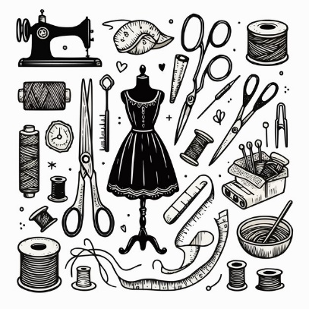

January 2025